Cross-quantilogram: NZDUSD and USDCAD
Method 20 / daily log returns / expanding quantiles / Alpari D1 full available history

Study setup
Logical pair: NZDUSD , USDCAD
Broker symbols: NZDUSD_i , USDCAD_i
Snapshot: 2026-11-03_majors_alpari_D1
Timeframe: D1
Matched return window: 1999-01-05 to 2026-11-02 (UTC bar dates)
Matched return count n: 7190
Dropped unfinished last bar dated 2026-11-03 UTC after a tick-volume check against the prior complete day.
Quantiles: expanding window, min history 252 days
tau in [0.05, 0.2]; k=0..10; headline tau=0.05, k=1
Complete matched rows (Excel): NZDUSD-USDCAD_CQ_D1.xlsx
Complete matched rows (HTML table): NZDUSD-USDCAD_CQ_D1_data.html

Method carried forward
The cross-quantilogram rho_tau(k) measures linkage among centered quantile-hit indicators of matched daily log returns of close, ln(close_t / close_t-1). Quotes are not inverted. At each date t, the tau-quantile uses only returns through t (expanding window) after a minimum history of 252 days. Hits are h_t = 1(r_t < q_t) - tau. rho_tau(k) is the normalized cross-product of h_x,t with h_y,t+k. Levels tau in {0.05, 0.20} and lags k=0..10 are pre-specified; headline is tau=0.05, k=1 both directions. Same-sample Pearson r is a side check. This is not causation and not a trading signal.

Results (headline)
rho_NZDUSD->USDCAD(tau=0.05,k=1): 0.062409
rho_USDCAD->NZDUSD(tau=0.05,k=1): 0.021526
rho_NZDUSD->USDCAD(tau=0.20,k=1): 0.056200
rho_USDCAD->NZDUSD(tau=0.20,k=1): 0.015341
Pearson r: -0.587831

CQ table (tau=0.05)
k | rho_NZDUSD_to_USDCAD | n_NZDUSD_to_USDCAD | rho_USDCAD_to_NZDUSD | n_USDCAD_to_NZDUSD
0 | -0.04765122 | 6939 | -0.04765122 | 6939
1 | 0.06240857 | 6938 | 0.02152616 | 6938
2 | 0.03430014 | 6937 | -0.00049531 | 6937
3 | 0.05948449 | 6936 | 0.07497323 | 6936
4 | 0.04058297 | 6935 | 0.02464796 | 6935
5 | 0.05632064 | 6934 | 0.04979949 | 6934
6 | 0.06890948 | 6933 | 0.0340674 | 6933
7 | 0.03111304 | 6932 | 0.0592194 | 6932
8 | 0.04055276 | 6931 | 0.03719718 | 6931
9 | 0.04054521 | 6930 | 0.03089962 | 6930
10 | 0.05943266 | 6929 | 0.03403702 | 6929

Conclusion
Headline tau=0.05, k=1 for NZDUSD and USDCAD: rho_NZDUSD->USDCAD = 0.0624; rho_USDCAD->NZDUSD = 0.0215. At tau=0.20, k=1: 0.0562 and 0.0153. Same-day tau=0.05 rho(k=0) = -0.0477. Pearson r = -0.5878. This is quantile-hit linkage, not a trading signal.

Charts
Daily closes

Daily log returns

Cross-quantilogram tau=0.05
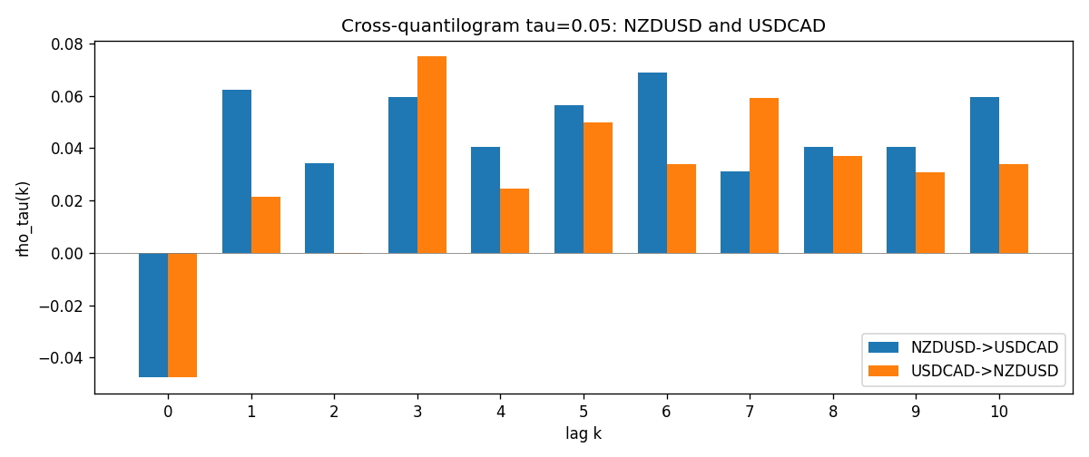

Data report
Matched rows and the CQ sheet are in the sibling Excel workbook named NZDUSD-USDCAD_CQ_D1.xlsx. Embedding all rows as a Word table is impractical; this file holds column summaries and the first and last 15 matched rows.
Columns: time, NZDUSD_open, USDCAD_open, NZDUSD_high, USDCAD_high, NZDUSD_low, USDCAD_low, NZDUSD_close, USDCAD_close, NZDUSD_tick_volume, USDCAD_tick_volume, NZDUSD_spread, USDCAD_spread, NZDUSD_real_volume, USDCAD_real_volume, NZDUSD_log_return, USDCAD_log_return, NZDUSD_h_t005, USDCAD_h_t005
Column summaries (matched calculation rows)
column | count | mean | std | min | 25% | 50% | 75% | max
NZDUSD_open | 7190 | 0.6563919 | 0.10821436 | 0.3913 | 0.5912925 | 0.6684 | 0.7249075 | 0.88218
USDCAD_open | 7190 | 1.2668559 | 0.16897553 | 0.9168 | 1.118445 | 1.298545 | 1.37213 | 1.6183
NZDUSD_high | 7190 | 0.66030697 | 0.10871111 | 0.3961 | 0.5947025 | 0.67202 | 0.72936 | 0.88421
USDCAD_high | 7190 | 1.2717549 | 0.16892987 | 0.9336 | 1.122975 | 1.30394 | 1.37655 | 1.619
NZDUSD_low | 7190 | 0.65270307 | 0.10781082 | 0.3897 | 0.5880525 | 0.664185 | 0.720965 | 0.87988
USDCAD_low | 7190 | 1.2623003 | 0.16901312 | 0.9056 | 1.114125 | 1.293585 | 1.36785 | 1.6102
NZDUSD_close | 7190 | 0.65646372 | 0.10821182 | 0.3907 | 0.5915625 | 0.66842 | 0.725015 | 0.8822
USDCAD_close | 7190 | 1.266877 | 0.16895077 | 0.916 | 1.118165 | 1.298615 | 1.372425 | 1.6137
NZDUSD_tick_volume | 7190 | 68672.777 | 123109.57 | 16 | 5561.25 | 33864.5 | 58508 | 1127682
USDCAD_tick_volume | 7190 | 80995.8 | 147287.89 | 37 | 5534 | 40938 | 71622.5 | 1410818
NZDUSD_spread | 7190 | 30.299444 | 25.655426 | 0 | 9 | 17 | 50 | 80
USDCAD_spread | 7190 | 23.448679 | 18.267866 | 0 | 9 | 17 | 40 | 60
NZDUSD_real_volume | 7190 | 1.6692087e+10 | 8.4955308e+10 | 0 | 0 | 0 | 0 | 2.705649e+12
USDCAD_real_volume | 7190 | 1.8371592e+10 | 9.6675129e+10 | 0 | 0 | 0 | 0 | 2.5751613e+12
NZDUSD_log_return | 7190 | 6.02e-06 | 0.00764513 | -0.07027433 | -0.00425619 | 0.00022347 | 0.00457637 | 0.05966839
USDCAD_log_return | 7190 | -9.38e-06 | 0.0051433 | -0.03859748 | -0.00283202 | 5.381e-05 | 0.00272817 | 0.03436319
NZDUSD_h_t005 | 6939 | -0.00546909 | 0.20628631 | -0.05 | -0.05 | -0.05 | -0.05 | 0.95
USDCAD_h_t005 | 6939 | 0.00202479 | 0.22209304 | -0.05 | -0.05 | -0.05 | -0.05 | 0.95
First 15 matched rows (selected columns)
time | NZDUSD_log_return | USDCAD_log_return | NZDUSD_h_t005 | USDCAD_h_t005
1999-01-05 | -0.0018597736 | -0.010131666 | nan | nan
1999-01-06 | 0.0020455609 | -0.0003306769 | nan | nan
1999-01-07 | 0.0062963171 | 0.0015202092 | nan | nan
1999-01-08 | -0.00055396548 | -0.0020495197 | nan | nan
1999-01-11 | 0.010290425 | -0.0035137769 | nan | nan
1999-01-12 | -0.0053157489 | 0.0066194721 | nan | nan
1999-01-13 | -0.0099742238 | 0.0045420214 | nan | nan
1999-01-14 | -0.00018564931 | 0.0069376546 | nan | nan
1999-01-15 | -0.00074294208 | -0.0056905671 | nan | nan
1999-01-18 | -0.0018597736 | 0.00098344542 | nan | nan
1999-01-19 | 0.0018597736 | 0.002748513 | nan | nan
1999-01-20 | 0.0040793678 | -0.0059646885 | nan | nan
1999-01-21 | 0.0040627941 | -0.0042823796 | nan | nan
1999-01-22 | -0.012051689 | 0.0025057712 | nan | nan
1999-01-25 | -0.0035504102 | 0.00085579808 | nan | nan
Last 15 matched rows (selected columns)
time | NZDUSD_log_return | USDCAD_log_return | NZDUSD_h_t005 | USDCAD_h_t005
2026-10-13 | 0.0047326165 | -0.0046395653 | -0.05 | -0.05
2026-10-14 | -0.0037306483 | 0.0015184751 | -0.05 | -0.05
2026-10-15 | 0.0047634855 | -0.0036101503 | -0.05 | -0.05
2026-10-16 | 0.0057501001 | -0.0034322068 | -0.05 | -0.05
2026-10-19 | 0.0018917133 | -0.0018835331 | -0.05 | -0.05
2026-10-20 | 0.0037199341 | -0.0037066008 | -0.05 | -0.05
2026-10-21 | 0.0030923331 | -0.00084691787 | -0.05 | -0.05
2026-10-22 | -0.0033035227 | -0.0026307268 | -0.05 | -0.05
2026-10-23 | 0.0030929853 | 2.85545e-05 | -0.05 | -0.05
2026-10-26 | -0.0028993932 | 5.7106554e-05 | -0.05 | -0.05
2026-10-27 | -0.00026399852 | 0.0025379458 | -0.05 | -0.05
2026-10-28 | -0.0097283914 | -0.0038379274 | -0.05 | -0.05
2026-10-29 | 0.00062190714 | -0.00011436495 | -0.05 | -0.05
2026-10-30 | 0.00019537668 | -0.0010298736 | -0.05 | -0.05
2026-11-02 | -0.0025962955 | 0.00061519094 | -0.05 | -0.05

